Lesson 1-2
Identification of organic substances
I. Element Definition
Discovery of carbon and hydrogen in organic matter.
1) Heating with copper(II) oxide.
When organic matter is heated with copper(II) oxide, carbon dioxide is released. Carbon dioxide is determined by the cloudiness of barite or lime water.
Progress of work: The sample for analysis is mixed with copper (II) oxide with a weight several times greater than its own, and heated in a dry test tube. When the exhaust gas is directed into barite water (an aqueous solution of Ba(OH)2), the formation of turbidity indicates the presence of carbon. The water droplets that form on the walls of the test tube represent the hydrogen contained in the sample to be analyzed.
Ba(OH)₂+ CO₂→BaCO₃ + H₂O
2) Heating with molybdenum trioxide
In this reaction, the organic matter converts yellow molybdenum trioxide to blue molybdenum tetroxide.
Progress of work: A few milligrams of the substance is mixed with molybdenum trioxide powder. The mixture is heated slightly, the formation of a blue spot indicates the presence of hydrogen.
Discovery of nitrogen, sulfur and halides in organic matter.
When using three different melting methods, each element is defined separately.
1. Melting with Na (metal).
2. Smelting with wetted slaked lime.
3. Melting with a mixture of potassium nitrate and sodium carbonate.
1) Melting with Na (metal).
As a result of the fusion of organic substances with Na (metallic) carbon is converted into carbon dioxide and nitrogen monoxide, sodium cyanide, sulfur into sodium sulfide, halogens are converted into sodium salts. These substances are used to determine nitrogen, sulfur and halogens.
Progress:
A few milligrams of the substance is mixed with a piece of Na (metal) in a dry tube and heated. Then the temperature is raised and Na completely melts, the mixture is left to cool at room temperature. Add 5 ml of methanol to separate unreacted sodium, add 2 ml of water, boil briefly and filter. Elemental analysis is carried out on the obtained filtrate.
Sulfur determination.
Progress:
To 0.2 ml of the filtrate add 1 drop of 5% lead acetate and acidify with 6N HNO₃. A black precipitate of PbS indicates the presence of sulfur in the filtrate.
Na₂S + CH₃COOH⎯→H₂S + CH₃COONa
H₂S + Pb(CH₃COO)₂⎯→PBS↓+ СН₃СООН
1. Add 0.1% solution of Na-nitroprusside (Na₂[Fe(CN)₅NO]) dropwise to 0.2 ml of the filtrate. A red color indicates the presence of sulfur.
Determination of nitrogen.
Carried out by cyanide ion.
Progress:
1. To 0.6 ml of the filtrate add one drop of 10% NaOH, one drop of 30% KF, and then 15-20 mg of iron sulfate. Heat for 1-2 minutes, then add 1 drop of 1% hydrochloric acid and boil. Add 6 n. sulfuric acid to dissolve iron oxide. If any color appears after a minute, this indicates the presence of nitrogen. KFe[(Fe(CN)₆)
2. 0.2 ml of the filtrate is acidified by adding 1 drop of 10% acetic acid. A few drops of copper acetate/benzidine reagent are added to this. The presence of a blue ring on the contact surface indicates the presence of an ion (CN), and hence nitrogen.
Definition of halogens.
Silver nitrate is used to determine halogens (chlorine, bromine and iodine) except for fluorine. If the presence of nitrogen and sulfur elements is detected as a result of melting, silver nitrate is used as a reagent.
Formation of cyanide and sulfide silver salts under the action of cyanide and sulfur ions.
To prevent this, the dissolved filtrate is acidified with nitric acid and boiled with Na (metal). When silver nitrate is added to the remaining solution, the formation of a white and pale yellow precipitate proves the presence of halogens. In the absence of nitrogen and sulfur, they melt with Na (metal), the filtrate is acidified with nitric acid, silver is checked with nitrate.
Elementary organic compounds (R-CH₂-Hal) with halogens (Hal.) in the molecule form halides under the action of zinc dust in an alkaline or acidic medium:
R-CH₂-Hal + Zn + H₂SO₄ → R-CH₃+ HHal + ZnSO₄
R-CH₂-Hal+Zn+3NaOH→R-CH₃+NaHal+Na₂ZnO₂+H₂O
Identification of the halide ions formed as a result of the reaction is carried out using the indicated characteristic reactions (see: identification of inorganic medicinal substances).
Fluorine and chlorine ions contained in organic medicinal substances are determined by the corresponding analytical reactions after the decomposition of the organic part of the molecule by an alloy of metallic sodium:
R-CH₂ Hal $\underset{→}{Na}$Na Hal
Iodine can be detected by heating an organic compound containing iodine in a test tube in a gas flame, or by treating it with concentrated sulfuric acid:
R
C
H
2
I
t
o
q

atı
.

H
2
S
O
4
I
2
As a result of the reaction, violet vapors of iodine or a purple color of the chloroform extract are observed.
An organioiodine compound can also be determined by melting it in a mixture of sodium carbonate and potassium nitrate:
R
C
H
2
I
K
N
O
3
,

N
a
2
C
O
3
t
o
N
a
I
After that, iodide ions are determined. This method can also be applied to compounds containing chlorine and sulfur in their molecule. Chloride and sulfate ions are determined by their respective reactions.
Beilstein test.
The chlorine atom in an organic molecule gives the Beilstein reaction (coloring the flame green when the drug is burned on a copper wire).

Joint determination of chloride, bromide, iodide ions
When melted with Na (metal), halogens are converted to sodium. If they are found together, the following test is used to distinguish between them.
Progress:
Shake 0.5 ml of the filtrate with the same amount of carbon tetrachloride and 3 drops of nitric acid. If a purple color appears in the organic layer, then an iodide ion is present.
The carbon tetrachloride layer is removed with a pipette. The mother liquor remaining in the test tube is again acidified with 2 ml of nitric acid, stratified with carbon tetrachloride. The red-brown color of the organic layer indicates the presence of bromine. When bromine is completely exhausted, the above procedure continues.
The organic part is separated, and when 3 drops of 5% silver nitrate are added, the formation of a white precipitate indicates the presence of a chloride ion.
Separation of ionized and non-ionized halogens
The presence of halogen is detected in the filtrate obtained by melting Na (metal). It is necessary to determine whether the halogen is in ionized or non-ionized form.
1. Ionized halogen. Ionized halogen compounds are soluble in water. Halogen is determined by silver nitrate (silver nitrate) in aqueous solutions and in solutions obtained by filtering the suspension. A positive result proves that the halogen is ionized.
2. Non-ionized halogen. A negative ionized halogen test means that the halogen is not ionized.
3. In the presence of both ionized and non-ionized halogen, a positive result should be obtained in this case both in the filtrate resulting from the melting and in aqueous solutions.
Progress of work: The sample for analysis is dissolved in water, acidified with nitric acid, ionized halogen is precipitated with silver nitrate. Extraction is carried out with an organic solvent. In the organic part, a non-ionized halogen-containing part is formed, and in the layer that does not pass into the organic part, an ionized halogen-containing silver salt is formed. Chlorine, bromine and iodine ions are determined in this part with 10% ammonium carbonate solution.
AgCl - soluble in ammonium carbonate;
AgBr - soluble in concentrated ammonia, insoluble in ammonium carbonate;
AgI is insoluble in ammonia and ammonium carbonate.
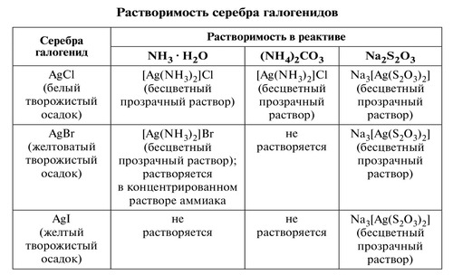
The resulting silver nitrate salt is soluble in ammonia, ammonium carbonate and sodium thiosulfate.
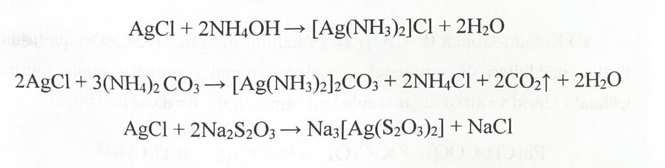
Definition of bromine.
Chloramine B is used in chloroform medium (the chloroform layer turns orange).
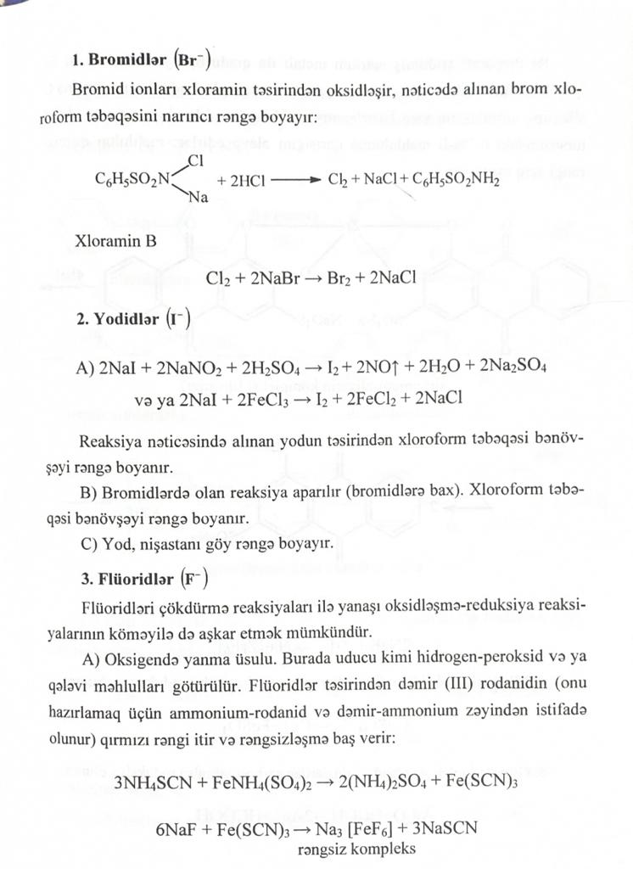
Determination of iodides.
- The resulting iodine stains the chloroform layer purple.
B) Iodine turns starch blue.

Determination of fluorides.
- Method of combustion in oxygen. A colorless complex of iron (III) thiocyanate is formed.
- reaction of formation of zirconium alizarin complex.
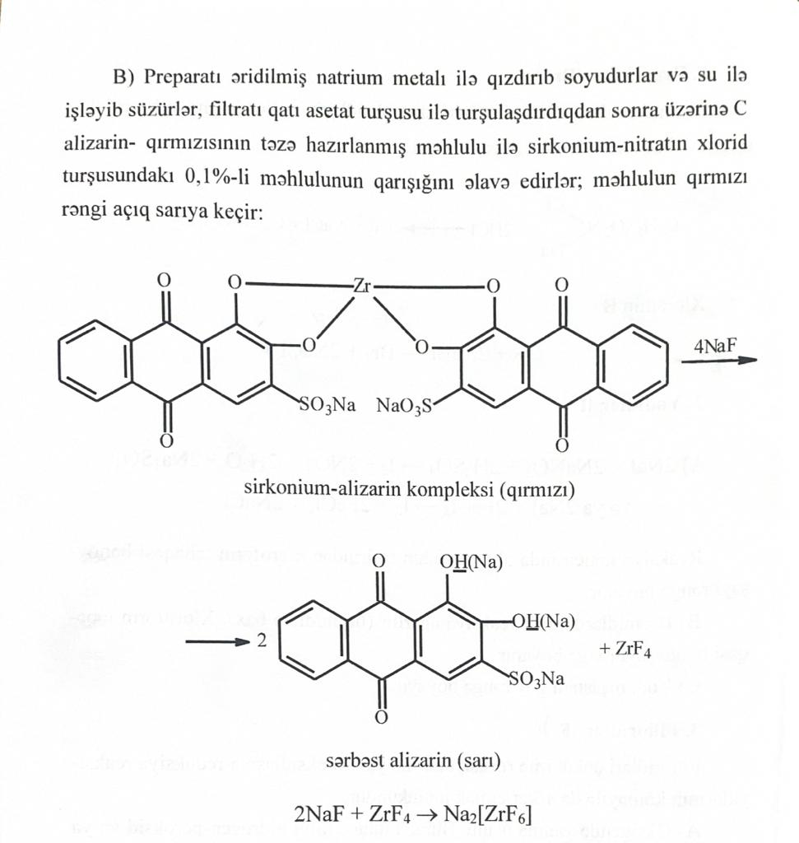
Zirconium-alizarin complex (red)
Free alizarin (blue)
Definition of fluorine
Determined with a titanium reagent. The titanate ions (TiO2) in the titanium reagent are oxidized to yellow pertitanate (TiO4) with the addition of hydrogen peroxide.
Progress of work: Use 2 tubes. 0.5 ml of the filtrate is added to one, and 0.5 ml of distilled water is added to the other. One drop of sulfuric acid and 2-3 drops of hydrogen peroxide solution (3%) are added to each. In the presence of fluoride ion, the tube with water is colored yellow, the tube with the filtrate is colorless (TiF6).
2. Smelting with wetted slaked lime
There is a search for nitrogen and halogen.
Substance (N, X) + CaO + NaOH→NaX + NH₃↑
Progress:
100 mg of organic matter is mixed with 200 mg of wetted slaked lime, heated in a non-alkaline dry tube. The blue color that occurs when a litmus paper moistened with water is brought to the gas outlet indicates the presence of nitrogen.
The determination of nitrogen in some compounds becomes difficult. If the test is negative, it is repeated. Distilled water is added to the residue remaining in the test tube after searching for nitrogen, mixed and filtered. In this filtrate, the halogen is alloyed with Na (metal).

3. Dissolution with KNO₃ и NaCO₃
Halogen and seua are determined. As a result of oxidation, sulfur turns into sulfate, and halogen into halide.
Progress:
Dissolve 50 mg of potassium nitrate in one capsule. 100 mg of KNO3, 100 mg of NaCO3 and 50 mg of organic matter are added to it. Melted in a muffle furnace. Cool, add water and filter. Part of the filtrate is acidified with solid hydrochloric acid and BaCl2 is added to search for the sulfate ion (BaSO4).
The other part is acidified with nitric acid and AgNO3 is added to search for the halogen.
Empirical Formula Calculation
At the end of the elemental analysis, when the percentage of each element in the compound is known, an empirical formula is calculated.
For example, if the parse result looks like the following:
C - 67.38%
H - 7.92%
H - 15.72%
O - 8.98%
The percentage of each element is first calculated by the atomic weight of that element, then these values are divided by the smallest value obtained in the first division.
C \u003d 67.38 / 12 \u003d 5.61 / 0.56 \u003d 10
H \u003d 7.92 / 1 \u003d 7.92 / 0.56 \u003d 14
N=15.72/14.01=1.12/0.56=2
O \u003d 8.98 / 16.00 \u003d 0.56 / 0.56 \u003d 1
The empirical formula of the compound turned out to be C₁₀H₁₄N₂O
If the molecular weight of the compound is 178 g.
178 (10 x 12+ 14 x 1+2 x 14 +1 x 16)n
n=1.
Therefore, the formula of the compound is C₁₀H₁₄N₂O
If the molecular weight of the compound is 356 g.
356 (10 x 12+ 14 x 1+2 x 14+1 x 16) n.
n=2. The compound formula is C₂₀H₂₈N₄O₂
Calculation of the number of double bonds.
The number of unsaturated bonds in a molecule is calculated using the following formula.
where N is the number of double bonds
ni is the number of atoms of element i in the molecule
vi is the valence number of the element.
The valency number C is - 4.
For H - 1
For O - 2
For halogen - 1.
The valence number for S - must be reported.
In this calculation, each C=C, C=O, C=N, N=O cyclic ring or any double bond system corresponds to one unsaturation. C=C and C=N 2 are considered unsaturated.
Coordinated covalent bonds =PO- and =S+-O are considered as single bonds.
For the empirical formula C₆H₆
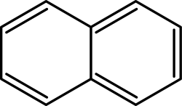
5 of them show C=C bonds, and 2 show rings.
For formula C₁₂H₉NS
Determination of solubility
Determining the solubility of a sample for analysis can provide information about its structure. Compounds that retain polar bonds are soluble in water, strong acids are soluble in sodium bicarbonate, bases are soluble in hydrochloric acid, the solubility of weakly acidic compounds in sodium bicarbonate provides some information before chemical analysis.
When determining the solubility take 30 mg of the sample and dissolve in 1 ml of solvent at room temperature. Substances with a crystalline structure are ground into powder, and the mixtures must be separated. Determination of solubility is necessarily carried out after elemental analysis. Solvents used: water, alcohol, 5% NaOH, 5% NaHCO3, 5% HCl, sulfuric acid.
Classification is carried out according to the following table:
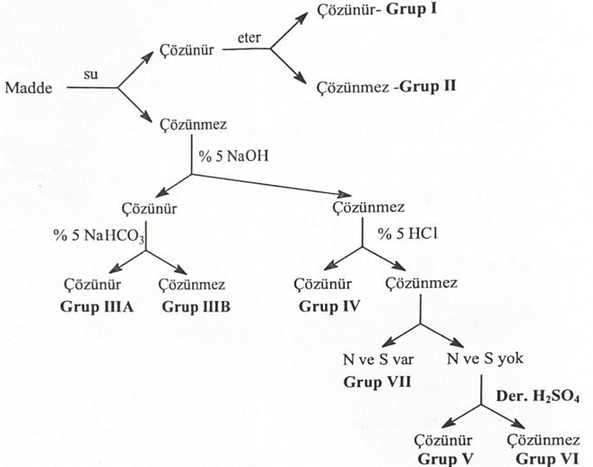
Group I - low molecular weight alcohols, aldehydes, ketones, anhydrides, phenols, amines, nitriles, halogen compounds.
Group II - polybasic and hydroxy acids, polyalcohols, polyhydroxyaldehydes and ketones, some amides, amino acids, amino alcohols, salts of organic acids of amines, metal salts of acids, sulfonyl acids, sulfinyl acids.
Group III-A acids, their anhydrides and halides, nitro- and cyanic acids, polynitrophenols, polyhalogenated phenols, some sulfonyl acids.
Group III B - phenols, enols, oximes, imides, amino acids, simple and double nitro compounds, sulfonamides. mercaptans, thiophenols.
Group IV - monoamines, secondary aliphatic and aralkyl amines, tertiary aliphatic and aralkylamines.
Group V - unsaturated hydrocarbons, some alkylated aromatic carbohydrates, high molecular weight aldehydes, alcohols, ketones, anhydrides, esters and acetyls, lactones, acyl halides.
Group VI - saturated aliphatic hydrocarbons, cyclic hydrocarbons, aromatic hydrocarbons and their halogen derivatives, diaryl ethers.
Group VII - nitro compounds, reduction products of nitro compounds, nitriles, anilides, some amides, electronegatively substituted amines, sulfites, sulfones, other sulfur compounds.

initial experiences.
Before proceeding to the functional group analysis, the aromatic structure, active unsaturation, acid structure are checked using iron (III) chloride and Dragendorff's reagent.
Determination of aromatic structure
Aromatic and polycyclic hydrocarbons with aluminum chloride or antimony pentachloride give colored compounds in chloroform. At the end of the characteristic Friedel-Kravz alkalization reaction, colored triphenylmethane compounds are formed. This reaction sharply distinguishes aromatic compounds and their chlorine derivatives from non-aromatic compounds and their chlorine derivatives.
Progress:
In a dry tube, 100 mg of aluminum chloride are heated, sublimated and cooled. From the edge of the test tube add 20 mg of organic matter dissolved in chloroform. The reaction is considered complete if a color appears at the point of contact. Monocyclic aromatic compounds are yellow, orange or red, bicyclic aromatic compounds are blue, purple, and more complex compounds are green.
Formaldehyde/sulfuric acid test
Aromatic and polycyclic hydrocarbons and their derivatives, unsaturated cyclic hydrocarbons give a characteristic color with formaldehyde/sulfuric acid. The formation of this color is due to the polymerization of carbon ions.
Aromatic structure + HCHO + H₂SO₄→Ар-СН₂-Ар-СН₂-Ар-СН₂---
Progress:
30 mg of the substance is dissolved in a non-aromatic solvent. By adding 1-2 drops of this mixture (1 ml of concentrated sulfuric acid and 1 drop of formalin), a color is obtained on the contact line of the reagents.
In this test, gasoline, toluene, n-butylbenzene have a red color. Secondary butylbenzene - pink, tertiary butylbenzene - orange, di- and triphenyls - blue, naphthalene and phenanthrene - green, naphthyl ethers - violet, non-cyclic unsaturated hydrocarbons - brown. Unsaturated hydrocarbons, unsaturated aliphatic hydrocarbons and cyclic saturated hydrocarbons do not enter into this reaction.
Definition of active unsaturation.
1. Bromine test: bromine water is added to active unsaturated compounds. In some functional groups, bromine becomes colorless due to a substitution reaction.
Progress:
50 mg of the sample is dissolved in a suitable solvent in a volume of 1-2 ml. Bromine water is added to it. If the bromine becomes colorless, the reaction is complete.
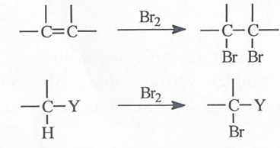
2. Permanganate test: alkenes, alkynes and easily oxidized compounds change the color of the permanganate ion.
Progress of work: 25-30 mg of the substance is dissolved in 2 ml of water or alcohol-free acetone. Add 1 drop of 3.2% KMnO4 and rinse. The disappearance of the purple color means that the reaction is positive.
3. Reaction with iron(III) chloride: Phenols, hydroxamic acids, some isonitriles, enolized compounds form a complex with iron(III) chloride, forming a purple or dark red color.
Progress:
10 mg of the substance is dissolved in 1-2 ml of water or alcohol. 3 drops of iron(III) chloride are added, the above colors or a precipitate are formed.
Acid structure detection.
Iodide-iodate test. Water-soluble acids containing iodide and iodate ions remove iodine from the solution.
Progress:
10 mg sample is dissolved in water or alcohol, 2 drops of 2% KJ and 2 drops of 4% KJ are added. Heat and cool in a water bath for 1 minute. Pink color indicates the formation of iodine. If the sample is soluble in alcohol, the addition of a freshly prepared 0.1% starch solution produces a blue color.
Dragendorff's reagent:
This reagent is used to determine nitrogen and third nitrogen in various rings. The reaction produces an orange color.

